**Technical Documentation – Deploy_MSC**

1. Workflow – Deploys MSC Tomcat Artifacts to an Environment.

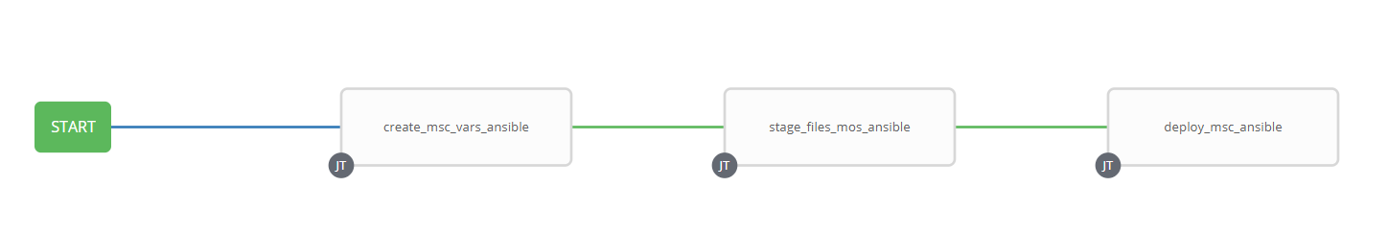

1. Survey – User Supplied Variables

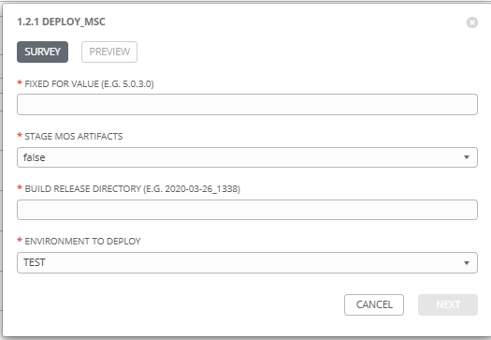

|  |  |  |  |
| --- | --- | --- | --- |
| **Survey Extra Variables** | **Prompt** | **Type** | **Description and Usage** |
| FFV | Fixed For Value | Text | The fixed for value for the deployment – must be for the format ###.###.###.### (i.e. 58.0.12.0). Numbers only with a maximum of 3 digits and there must be 4 sets separated with a ‘.’. Used to create staging and deployments directories. Used by all job templates in the workflow |
| STAGE | Stage MOS Artifacts | Multiple Choice Single Pick | True or false – Copies the MSC Artifacts from the MOS Build Releases Directory to the Staging folder. |
| ReleaseDir | Build Directory | Text | The /pencmw_common/MOS/releases/ subdirectory that contains the MSC artifacts |
| ENV | Deploy to Which Environment | Multiple Choice Single Pick | The Environment to Deploy to: DEV, TEST, MAINT or PROD. Only a single environment can be deployed to per workflow execution |

1. Jobs Used by the workflow - http://owl.penc.local:18080/svn/deploy_automation/trunk/Ansible_PlayBooks/MOS

| **Job Template** | **Ansible Playbook** | **Project** | **Description and Usage** |
| --- | --- | --- | --- |
| create_msc_vars_ansible | create_msc_vars_ansible.yml | MOS/MEX Deployments | DeploymentLogDir: /codemove_common/dp_automation/deployments/068.000/068.000.014.000/MOS  StageDir: /codemove_common/dp_automation/stage/068.000/068.000.014.000/MOS  date_time: '20200505_0743'  deployment_host: tbusserv1bcp  stage_server: diagoras1bcp |
| stage_files_mos_ansible | stage_files_mos_ansible.yml | MOS/MEX Deployments | Copies MOS Services Artifacts from /pencmw_common/MOS/releases/{{ReleaseDir}} to the {{StageDir}}/{{ReleaseDir}}  The job fails if the /pencmw_common/MOS/releases/{{ReleaseDir}} build directory does not exist.  If the stage_server is set to ‘none’ as opposed to diagoras1bcp, the playbook does not actually do anything, all of the tasks are skipped.  The last task of the job creates a Staging Report in the {{DeploymentLogDir}} in html format.  Note: that this Job Template is used by the Full MOS Deployment, Incremental Business Services Deployment and WES Deployment workflows. |
| deploy_msc_ansible | deploy_msc_ansible.yml | MOS/MEX Deployments | Deploys MSC Artifacts to the {{ENV}} environment and then restarts the MSC Tomcat Server.  It also populates an html formatted deployment log {{DeploymentLogDir}}/{{ReleaseDir}}/{{ansible_host}}_MSC_Deployment_Log_{{date_time}}.html |